**Analysis and Design document**

Team Name : **STARS**

Team Members : SATYA VENKATA KRISHNA ACHANTA

ROBIN KUMAR

SHIVA SAI GOUD PABBA

Title : FUN BOX

Category : ANDROID BASED MOBILE APPLICATION

Key words : Monitoring each screen

Game play

Menu

**ANALYSIS**

Analysis is the detailed study of the various operations performed by a system and their relationships within and outside of the system.

During analysis, data are collected on the available files, decision points, and transactions handled by the present system.

This section attempts to describe each Activity of the project in brief, and the detailed description of each of these Activities and Actions is spread throughout this document.

This Squeeze Box Gaming Application consists different Sectors, They are

* Start Screen

It have 3 utility options as described below, user can choose what application he want to play from FUNBOX app

Number guessing game

* New Game
  1. This function is initiated at the initial screen when the new game button is pressed. After the button is pressed, it goes to next window and Ask for input from user, then passes of the responsibility to the main game function.
  2. Taking Input

In order to produce a result it takes required input from the user

* 1. Displays number

If user gives right answer or exceeds max number of tries it appears with appropriate results

Buddy search

1. Asking for name of user

It process the input with some certain logic

1. Prints name

It displays the result to the user and first letter of your friend

Monty hall

1. Picks a door number

User can choose any door from total number of doors

1. Confirmation

Asks for final decision to switch the door with other

1. Unlocks all doors

It displays all doors

1. Produces result

It produces prizes based on selected results

1. Exit Game

This function exits the game’s main menu back to the game suite’s main menu

## Use Cases diagram

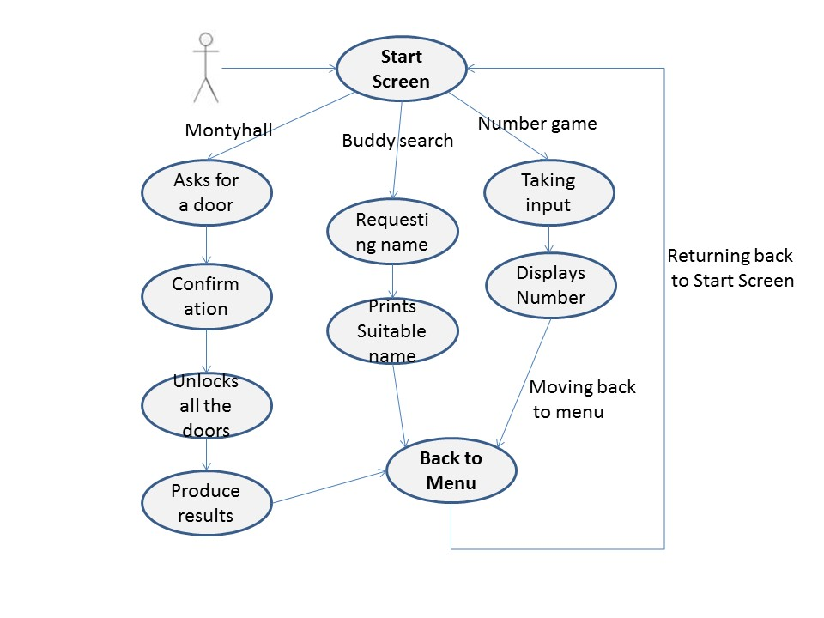

Use Case diagram

## Use Case descriptions

|  |  |
| --- | --- |
| **Name:** | Start Screen |
| **Actor:** | User |
| **Entry**  **Conditions:** | Application is running.  A Game is not currently in progress. |
| **Flow of**  **Events:** | 1. PLAYER initiates a new Game among three options  2. SYSTEM presents PLAYER with NewGameForm |
| **Exit**  **Conditions:** | Game is now in a new state. |

|  |  |
| --- | --- |
| **Name:** | Choose a application |
| **Actor:** | User |
| **Entry**  **Conditions:** | A Game is currently in progress |
| **Flow of**  **Events:** | 1. PLAYER initiates new game function  2. SYSTEM confirms that the PLAYER wishes to continue.  3. SYSTEM presents PLAYER with New Game Form |
| **Exit**  **Conditions:** | Game is now in a new state. |

|  |  |
| --- | --- |
| **Name:** | Ask For Decision to choose a door |
| **Actor:** | User |
| **Entry**  **Conditions:** | It is the initiating user turn  Game is not finished |
| **Flow of**  **Events:** | 1. PLAYER selects a door from the three doors. 2. SYSTEM ask for final decision or to switch door. 3. SYSTEM confirms that the PLAYER wishes to continue |
| **Exit**  **Conditions:** | Make final decision for door |

|  |  |
| --- | --- |
| **Name:** | Unlocks Door |
| **Actor:** | User |
| **Entry**  **Conditions:** | Shows result |
| **Flow of**  **Events:** | 1. SYSTEM refreshes and display to show the what is behind the doors |
| **Exit**  **Conditions:** | The game is in a finished state  And Goes back to Menu |

|  |  |
| --- | --- |
| **Name:** | NumberGuessingGame |
| **Actor:** | User |
| **Entry**  **Conditions:** | A Game is currently in progress |
| **Flow of**  **Events:** | Ask to Guess a Number |

|  |  |
| --- | --- |
| **Name:** | Input a Guess (Number) |
| **Actor:** | User |
| **Entry**  **Conditions:** | Ask for Number  Game is not finished |
| **Flow of**  **Events:** | 1. The Player try a guess  2. System respond with Guess is Higher Or lower Than actual Number  3. SYSTEM updates the state of Given Number Till certain number of tries |
| **Exit**  **Conditions:** | The displays chosen Number after Number of tries |

|  |  |
| --- | --- |
| **Name:** | Shows result |
| **Actor:** | User |
| **Entry**  **Conditions:** | The game is in a finished state |
| **Flow of**  **Events:** | 1. Takes several Inputs from user  2. Gives result that user won or lost |
| **Exit**  **Conditions:** | The game is in a finished state  And Goes back to Menu position |

|  |  |
| --- | --- |
| **Name:** | Buddy Search |
| **Actor:** | User |
| **Entry**  **Conditions:** | A application is currently in progress |
| **Flow of**  **Events:** | 1. PLAYER Gives the required Input |
| **Exit**  **Conditions:** | SYSTEM process input for the relevant Match. |

|  |  |
| --- | --- |
| **Name:** | Displays Number |
| **Actor:** | User |
| **Entry**  **Conditions:** | The application is in a finished state |
| **Flow of**  **Events:** | Give back the output with match based on given output |